**Midterm Exam**

**St. Name: Krishnan, Ramya**

**St. ID: A20506653**

**Note: No Handwriting will be Accepted; Type all Answers**

***10 points for every question***

**Q1**. Explain how the requirements may become a risk factor for the software project plan.

Requirement is the crucial part of the software project plan. If the requirement is not clear, subsequent steps will be impacted.

Example, If the requirement document is not clear or ambiguous, then it will impact the design phase of the project plan and so on.

Below are some risks involved in requirement creation,

1. Incomplete
2. Unclear
3. Inaccurate
4. Ambiguity
5. Not doable
6. Not cost effective

**Q2**. Which one is better a network diagram with few Zero-Slack activities or many Zero-Slack activities? Explain.

A network diagram with few Zero slack activities is better than many zero slack activities. Slack time is the number of days by which a task can be delayed without impacting the completion date of the project. Formula for calculating slack time is

Slack Time = Last Finish Date – Early Finish Date

It is difference between Last finish date and early finish date. So, if we have many tasks with zero slack time, then the project will have burden to complete the project on time with no buffer time.

Hence, it is better to have few zero slack activities.

**Q3**. What would the ratio of ( (BCWS/ACWP) < 1) tell us about the project status?

BCWS and ACWP is used to calculate the cost performance Index of the project.

CPI = BCWS/ACWP

If CPI is less than 1, then it means, the project Actual cost is exceeded the Budgeted cost, which indicates over spent.

**Q4**. Explain the difference between desk review and group review when performing peer-review for the different software artifacts produced as a result of following the project plan and the development process. Give examples for when we should use desk reviews and when we should do group reviews.

Desk review is done by one person with out scheduling any formal meeting. It is an informal peer- review. There is no moderator required and meeting notes will not be collected.

Group review requires scheduled meeting with moderator present, who will conduct the meeting and collects data (start and end time, defects identified, re-review process etc.) Group review involves, planning, Preparation for review, review meeting, rework and follow up which is a expensive process.

Products that are small in size shall go for desk review which is not expensive. Also, for small sub activities, desk review will be useful.

**Q5**. Who controls the design review meeting? What are the different metrics collected in the review meeting?

Design review meeting is conducted by the moderator. Moderator can be anyone from the available resource pool. Moderator is responsible for below activities,

1. Records, meeting start and end time.
2. Time spent in preparation of the meeting
3. Defects found during the review meeting

Also, below metrics are collected during the design meeting,

1. If Design covers the requirement.
2. Design is correct and valid
3. It is as per the approved model
4. If the design is Doable
5. If it is possible to test the requirement

**Q6**. Can reviews and inspections tasks replace/eliminate the testing tasks? Explain.

No, reviews and inspections tasks cannot replace the testing tasks.

Review and inspections are performed at every activities (Design, Development, Documentation etc.) is to ensure that artifacts created at that stage is as per the procedures and best practices and covers the requirements.

For example, at the Coding activity, review and inspections are to ensure, the code written is as per the design document and the best practices are followed.

But, testing is to check the quality of the entire software project that is developed. It checks if the product satisfies all the requirement and as per the specification.

Hence, it is not possible to replace testing with reviews and inspections.

**Q7**. From the perspective of software project management, explain how a quality process is the prerequisite for a quality product.

In software project management, quality process ensures that all the best practices are followed as per the standards, example, Review, Testing, Rework etc.

Testing will check if the product is as per the customer specification.

Audit will check if the process is followed as per standard. By doing with project team will be able to deliver a quality product which can satisfy the client requirments.

**Q8**. What are the possible actions that the project manager and review moderator might consider to take for the following outcomes of design reviews?

1. Rework and defect fixes turned out to require more than 62% of the original effort to write the design.

If the rework is more then 62% which is above upper bound 50%, then it means, the Program engineer or system engineer did not understand the requirement clearly and lack the skillset to complete the project successfully. Below are the actions that can be taken at this case,

1. Replace the existing engineers with skilled experienced engineers
2. Assign the existing engineers with trainings that they need to acquire the required skillset
3. Rework and defect fixes turned out to require 18% of the original effort to write the design.

Lower bound of rework allowed is 10% hence in this case, activities are executed properly and requires minimal fixes. Below are the actins that will be taken at this case,

1. Keep the same engineers to fix the defects
2. Once defects fixed, moderator will schedule for one more review with reviewers for the rework done.
3. Rework and defect fixes turned out to require 3% of the original effort to write the design.

This is less than the lower bound, hence, the project is in good shape. Below are the actions that will be taken at this case,

1. Keep the same resources to fix the defects
2. Once defects are fixed, no re- review is required. They can proceed with further tasks.

**Q9**. Consider the following milestone table, what is the milestone trend chart that the following project follows? Name and draw the milestone trend chart.

|  |  |  |
| --- | --- | --- |
| **Milestone** | **Expected Delivery** | **Actual delivery** |
| Project Planning | 1st month | on-time |
| Lab/Environment Installation | 2nd month | early 1 week |
| Requirement Phase | 3rd month | early 1 week |
| Analysis phase | 4th month | early 1 week |
| Design phase | 5th month | early 2 weeks |
| Coding | 6th month | early 2 weeks |
| Testing | 7th month | early 2 weeks |
| Documentation | 8th month | early 3 weeks |
| Installation/Training | 9th month | early 3 weeks |

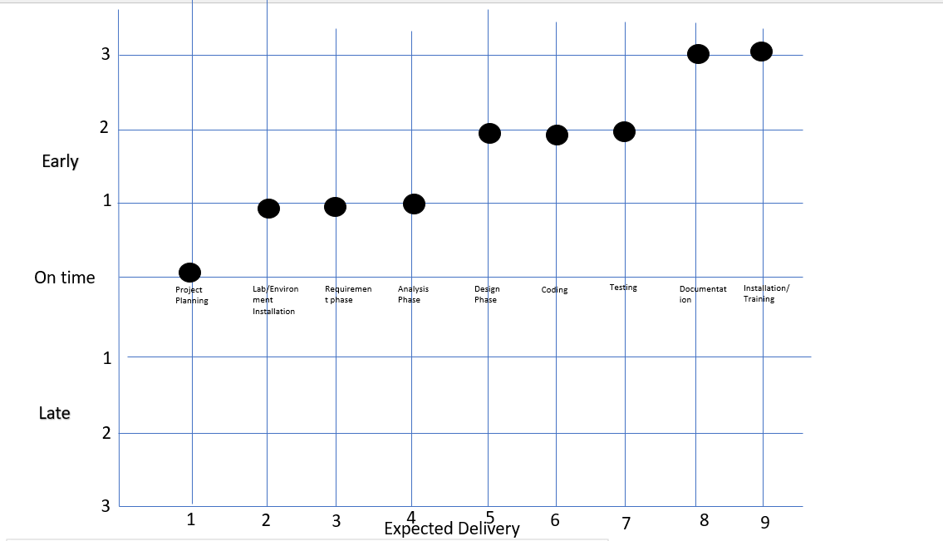

**It is a Successive run milestone.**

**Q10.** Consider the following data; calculate the effort and duration required for every task, considering the following constraints:

1. An artifact is produced by only one author
2. Every review “meeting” task shall be carried out by 5 engineers including the author
3. Every review “preparation” task shall be carried out by 4 engineers excluding the author
4. Any “Rework” task can be executed by the author of the original task

|  |  |  |  |  |
| --- | --- | --- | --- | --- |
| **Tasks** | **Amount of Work** | **Productivity** | **Effort** | **Duration** |
| High Level Design (HLD) |  |  |  |  |
| Write HLD Document | 70 pages | 5 page/Hour | 1.75 | 1.75 |
| Review HLD Document |  |  |  |  |
| Preparation for HLD Document |  | 5 pages/Hour | 1.75 | 0.4375 |
| Review Meeting |  | 8 pages/Hour | 1.09375 | 0.21875 |
| Rework | 30 defects | 2 defect/Hour | 1.875 | 1.875 |
|  |  |  |  |  |
| Low Level Design (LLD) |  |  |  |  |
| Write LLD Document | 70 pages | 1 page/Hour | 8.75 | 8.75 |
| Review LLD Document |  |  |  |  |
| Preparation for LLD Document |  | 5 pages/Hour | 1.75 | 0.4375 |
| Review Meeting |  | 10 pages/Hour | 0.875 | 0.175 |
| Rework | 40 defects | 1 defect/Hour | 5 | 5 |
|  |  |  |  |  |
| Testing |  |  |  |  |
| Write Test Plan | 48 pages | 3 pages/Hour | 2 | 2 |
| Review Test Plan |  |  |  |  |
| Preparation for Test Plan |  | 5 pages/Hour | 1.2 | 0.3 |
| Review Meeting |  | 10 pages/Hour | 0.6 | 0.12 |
| Rework | 52 defects | 3 defects/Hour | 2.17 | 2.17 |